# MINI PROJECT (2020-21)

**Fresher’s Solution**

# MID-TERM REPORT



**Institute of Engineering & Technology**

**Submitted by- Mandvi Rai (181500362)**

**Pragya Sharma**

**(181500464)**

**Manav Singh (181500360)**

**Shivani tyagi (181500680)**

***Supervised By:***

# Mr. Manoj Varshney

Assistant professor

**Department of Computer Engineering & Applications**

**Contents**

|  |  |
| --- | --- |
| **Abstract** | **3** |
| **1. Introduction** | **4** |
| 1.1 What is Fresher’s Solution? | **4** |
| 1.2 About the project | **4** |
| * 1. Hardware and Software Requirements   2. Technology used | **5** |
| **2. Objectives** | **6** |
| 3**. Implementation Details** | **6** |
| **4. Progress till Date & The Remaining work** | **7** |
| **5. Some Screenshots** | **8** |
| **6. References** | **18** |

**Abstract**

In this we will build a Fresher’s Solution site. After creating the Fresher’s Solution site, you will be able to take the notes for your corresponding subjects which was provide by the developers, and you are also able to practice your basic knowledge with the help of quiz Which was in this website and we also provde some blogs which was helpful to motivate students for deeper knowledge and extracurricular activities.

This technology helps you to provide best notes on your subject bases and give extra knowledge along with your course.

# Introduction

* 1. **What is Fresher’s Solution?**

The project Fresher’s Solution is a website which is an E-learning based platform and it will help the first year students of B.Tech (All Branches) .

It provides a convenient solution to the traditional notes-making system. We follow a modular approach of learning through our website. Building out the core administratio n system before moving on to complete individual learning modules, each with their own specific goals and objectives.

# About the project

The aim of this project is to make a website for first year students of our university. This is an e-learning website where first year students of our university will get ready-made notes. Our website “Fresher’s Solution” is to automate the existing manual system by help of ready-made notes, fulfilling first year students requirements so that they can receive valuable education.This means no need to worry about making handwritten notes. And they can utilize their time upto maximum. It is the need of time to switch on e-learning.

## The main objectives are :

* + 1. To provide a quality based education.
    2. To provide ready made notes.
    3. I-Q Test

# Hardware Requirements

* I3 processor based computer DDR3
* 4GB RAM
* 5 GB Hard disk space

# Software requirements

* + Windows 10
  + Visual Code Studio
  + Xampp

# Technology used

* + JAVA
  + CSS
  + JAVASCRIPT
  + PHP
  + MYSQL

**Objective**

The main objectives of the creating the Fresher’s Solution, We will provide all the notes regarding your subject and quizzes regarding to that particular subject which provide you the basic knowledge of that particular subject and we wil also give vlogs to fresher’s to motivate themselves for extracurricular activities.

# Implementation Details

**Part 1:** To build a Backend of the website in which notes are to be attached.

**Part 2:** Develop a site for quiz regarding to that particular subject.

**Part 3:** To build the information of developers.

**Part 4:** Provide the vlogs to motivate student for extracurricular activities.

1.) Part 1 is Pending

# Progress

## To build a Backend of the website in which notes are to be attached.

* + - Provide the notes to the web page.
    - Update the notes regularly.

2.) Part 2 is pending

## Develop a site for quiz regarding to that particular subject.

* + - **3 Subject quiz is completed and rest of the quiz is pendig.**

3.) Part 3 is completed

## To build the information of developers.

* + - Information of all the developers
    - All the social sites through which you can contact to them.

4.) Part 4 is completed

## Provide the vlogs to motivate student for extracurricular activities .

* + Vlogs regarding competitive exams.
  + Vlogs regarding sports.
  + Vlogs regarding Film industry.

# SCREENSHOTS

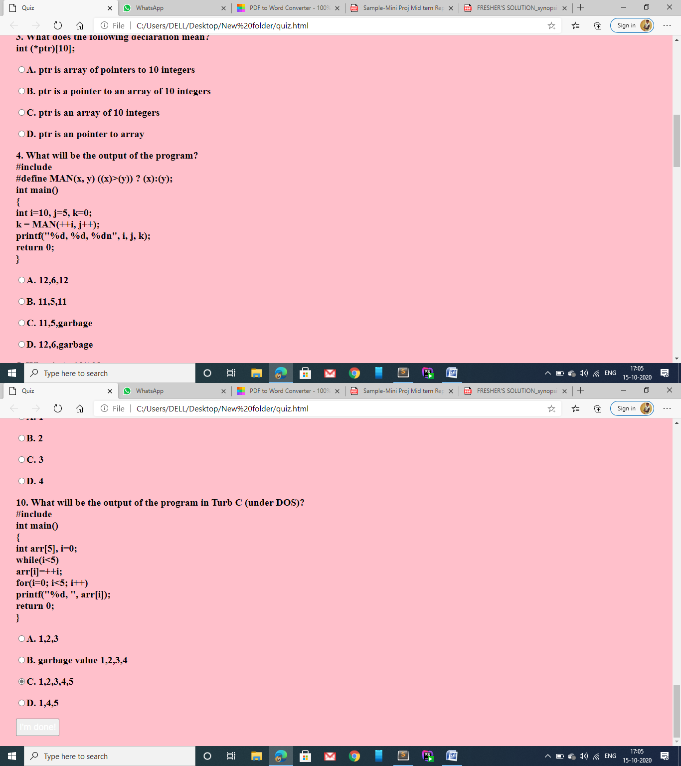

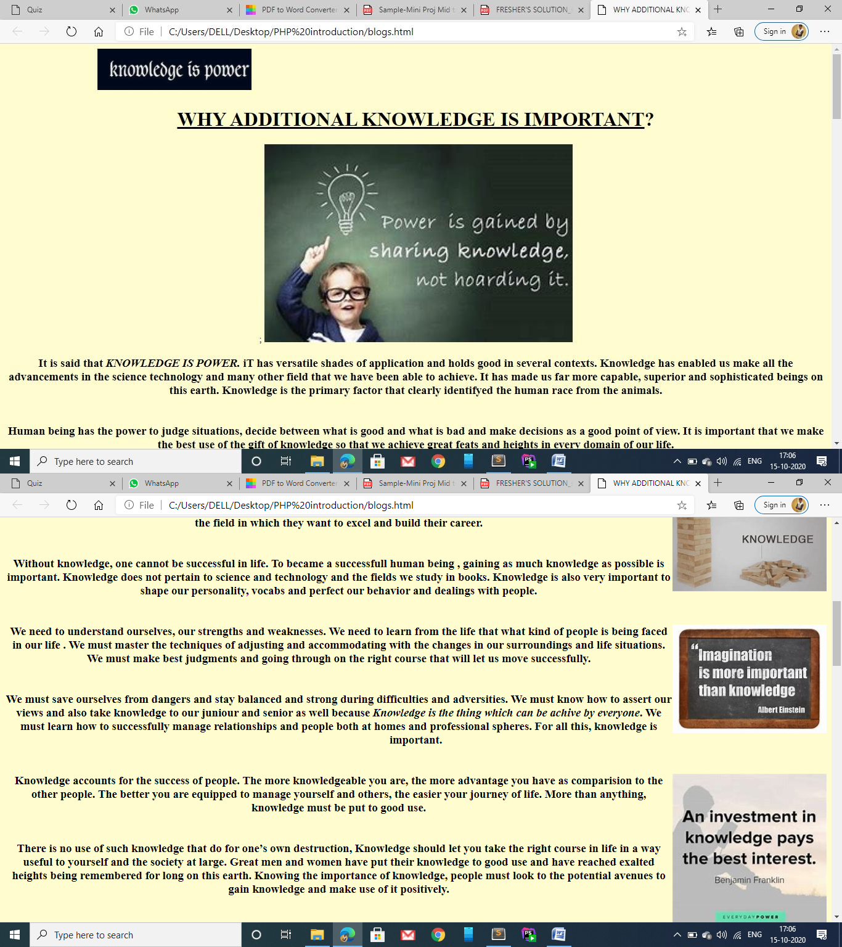

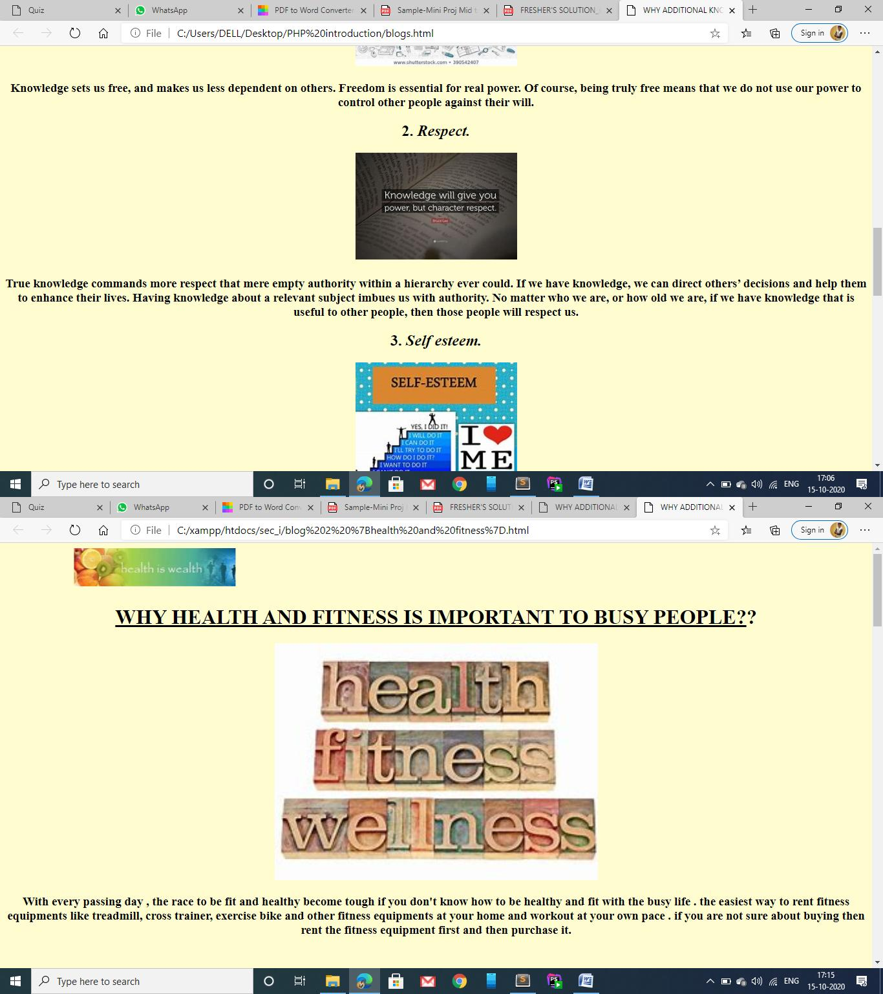

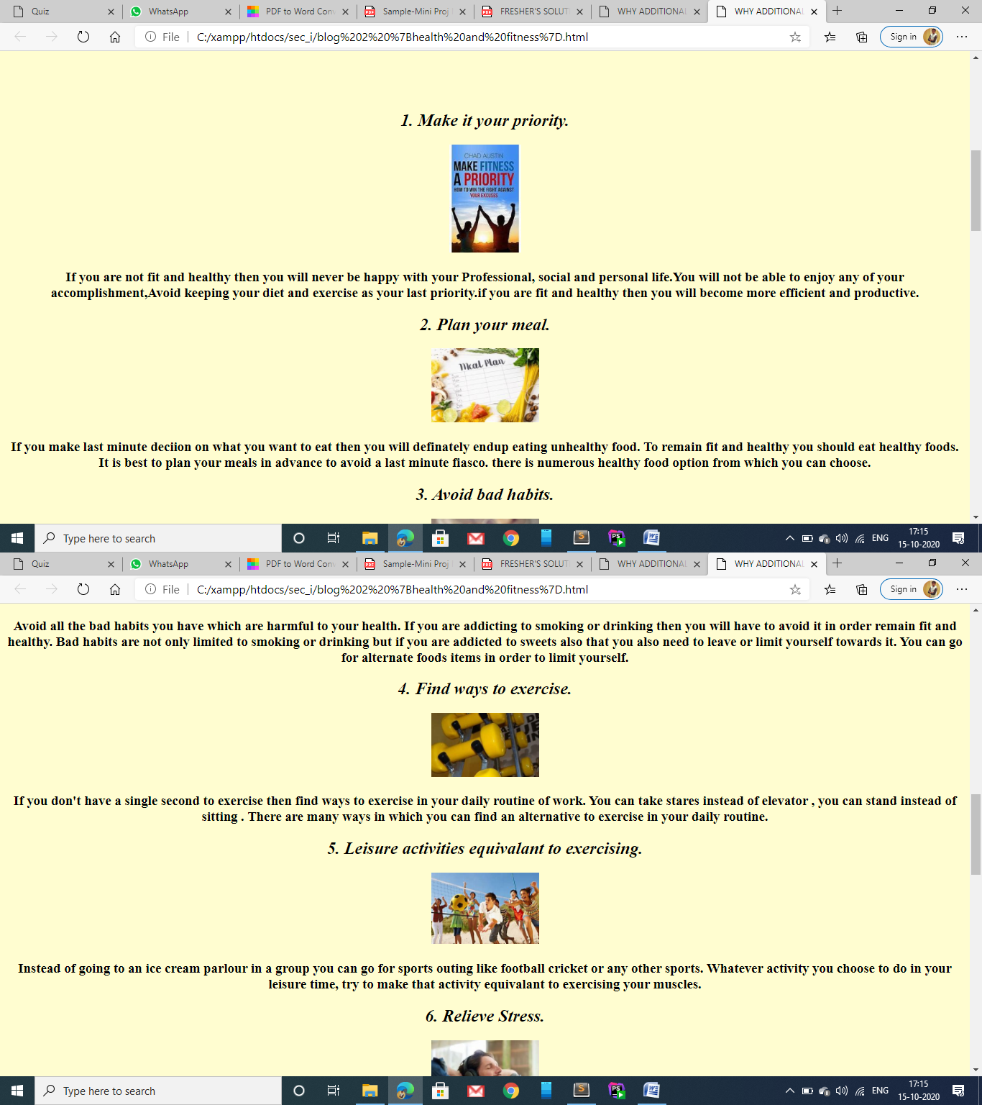

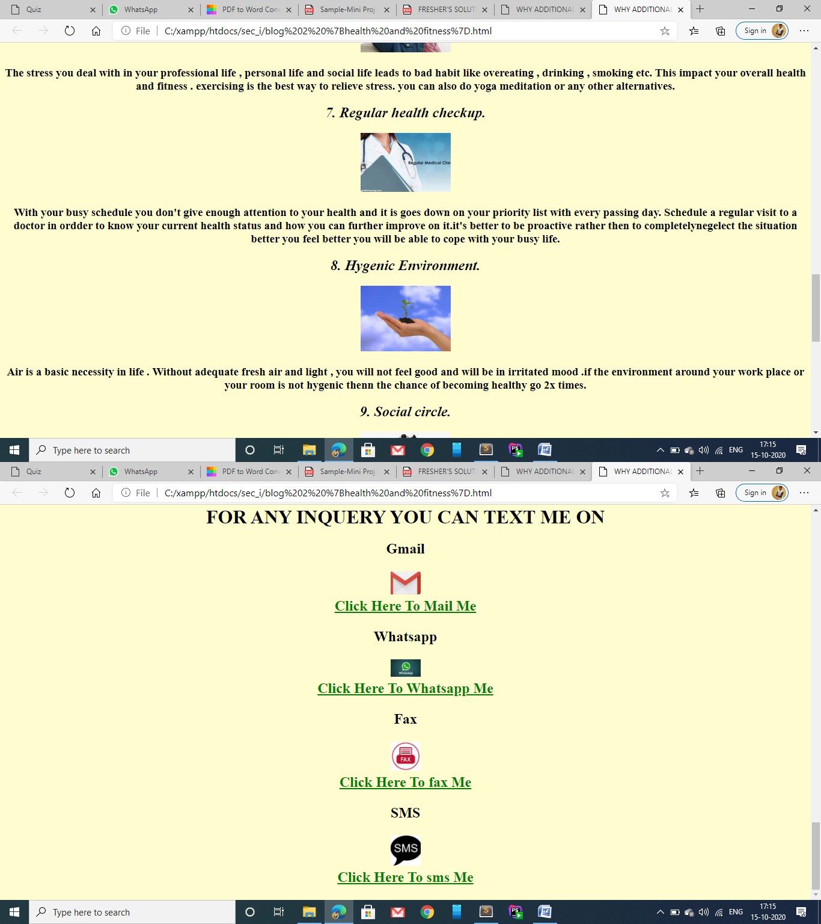

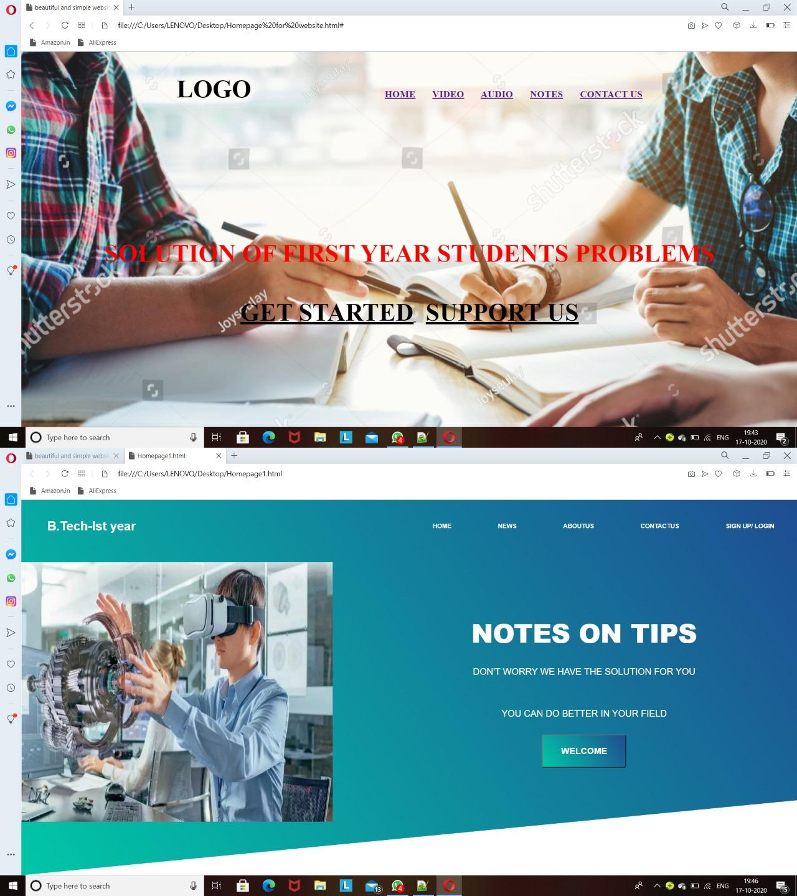

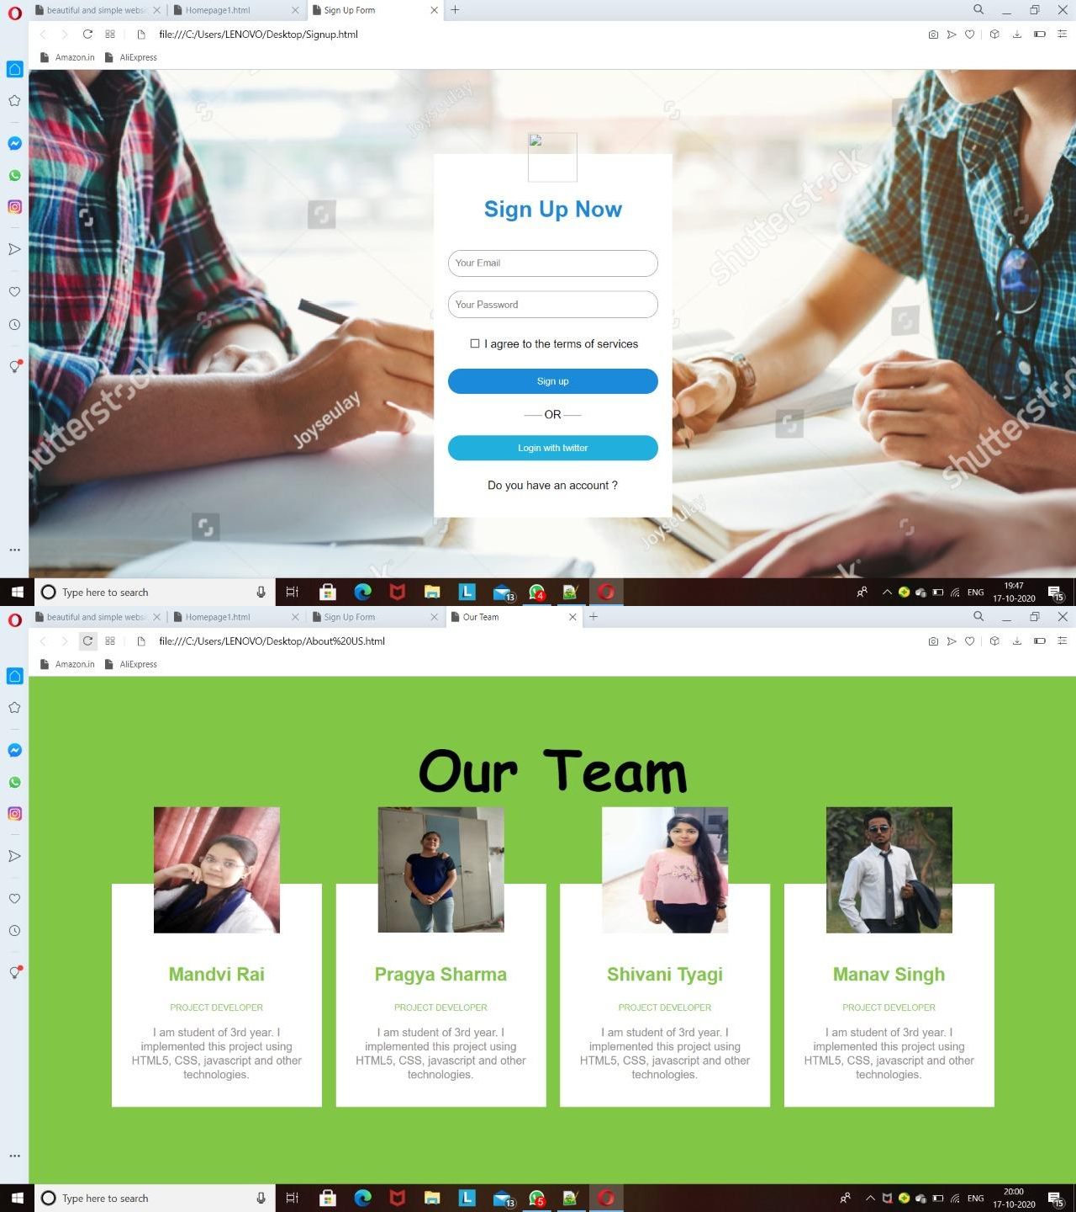

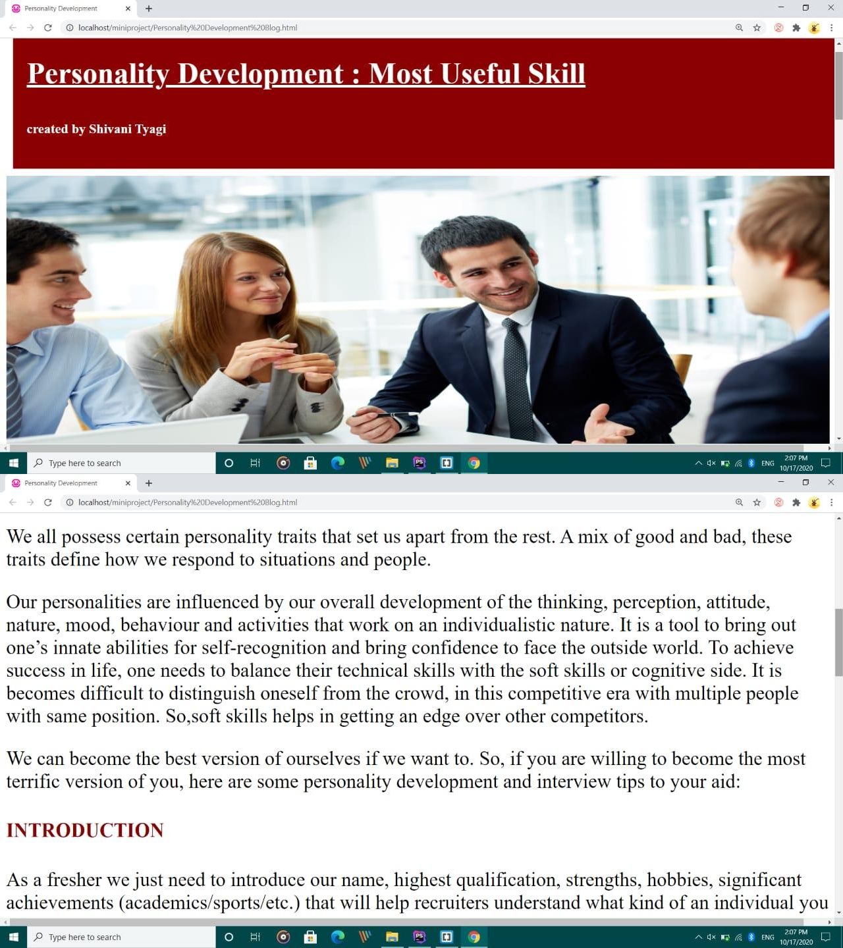

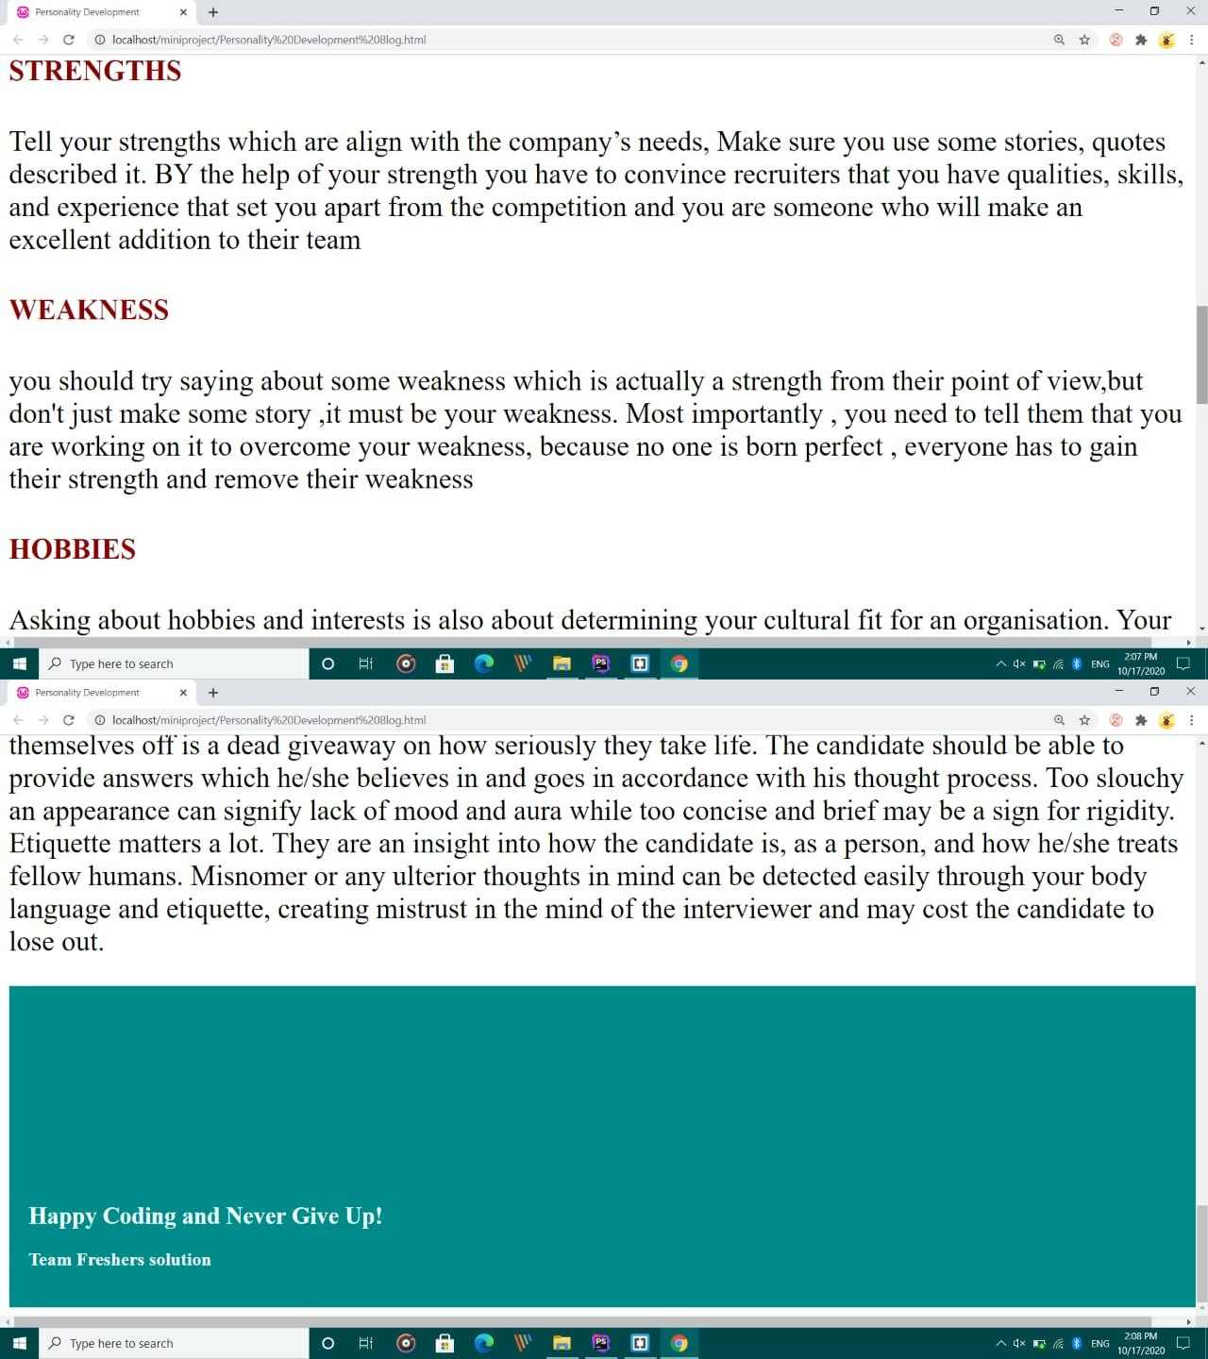

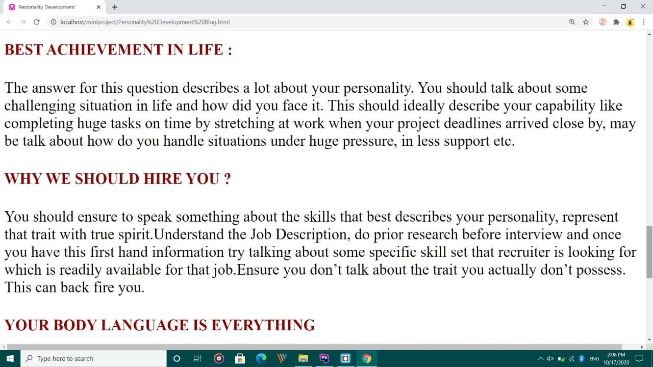

**References**

* + https://youtu.be/lacpTQuE9u8
  + https://youtu.be/qYWYEnw1zTI